|  |  |  |
| --- | --- | --- |
|  | **BAHRIA UNIVERSITY, (Karachi Campus)**  *Department of Software Engineering*  **Assignment 3 - Spring 2022** |  |

COURSE TITLE: Engineering Management COURSE CODE: **MGT-423**

Class: **BSE-IV (B)** Shift: **Morning**

Course Instructor: **Engr. Talha Bin Saeed** Time Allowed:  **1 Week**

Submission Date: **08/06/2022** Max. Marks: 05

**Name: Abdul Quddos Enrollment No: 02-131202-033**

**[CLO4: 5 Marks]**

**QUESTION #01**

Evaluate the R&D process that is required to develop a better product?

**Ans:**

**Selecting R&D Projects:**

**Need for Selection:**

Any successful technology-based manufacturing firm will have many more ideas for research projects than it has resources to invest in them. Booz, Allen, and Hamilton, Inc. has suggested approximately the following ratio of raw new product ideas to profitable products.

* Sixty ideas (from researchers, other employees, customers, and suppliers) need to be screened quickly down to.
* Twelve ideas worthy of preliminary technical evaluation and analysis of profitability, to produce.
* Six defined potential products worth further development, to obtain. 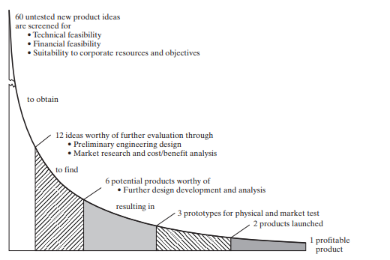
* Three prototypes for detailed physical and market testing, resulting in
* Two products committed to full-scale production and marketing, of which
* One product should be a real market success.

**Intial Screening:**

To slash 60 crude ideas into 12 worthy of any significant evaluation requires a method that is quick and inexpensive. A common method is use of a simple checklist, in which the proposed product is given a simple judgmental rating (poor/fair/good/excellent or -2> -1> +1> +2, for example) for each of a number of characteristics. Seiler suggests, for example, scoring 10 items:

1. Technical factors (availability of needed skills and facilities; probability of technical success).
2. Research direction and balance (compatibility with research goals and desired research balance).
3. . Timing (of R&D and market development relative to the competition).
4. Stability (of the potential market to economic changes and difficulty of substitution)
5. Position factor (relative to other product lines and raw materials)
6. Market growth factors for the product
7. Marketability and compatibility with current marketing goals, distribution methods, and customer makeup
8. Producibility with current production facilities and manpower
9. . Financial factors (expected investment need and rate of return from it)
10. Patentability and the need for continuing defensive research.

Only slightly more sophisticated is the use of a weighted checklist or scoring model in which each factor is scored on a scale, often from 0.0 to 1.0. A relative weight representing the importance of that factor is then used as a multiplier, and the weighted scores for all factors are added. Table 9-3 provides an example of such a scoring model. In this example, a potential new product 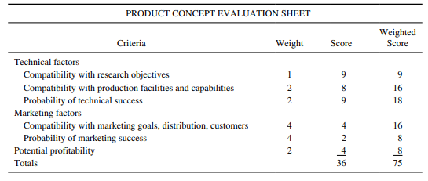

has been given a raw score of 36 (60 percent of the maximum 60) and a weighted score of 75 (only 50 percent of the maximum 150). The product was judged very favorably on technical factors and could be developed with some confidence of technical success. However, it was rated poorly on its marketing factors (which had been assigned greater weight in the model) and therefore probably would not be developed.